# Apply filters to SQL queries

## Project description

In this lab, the main objective is to retrieve crucial information from the database for the use of enhancing security of the organization. In order to do so, I need to filter out unwanted entries to grasp a better view of the data.

## Retrieve after hours failed login attempts

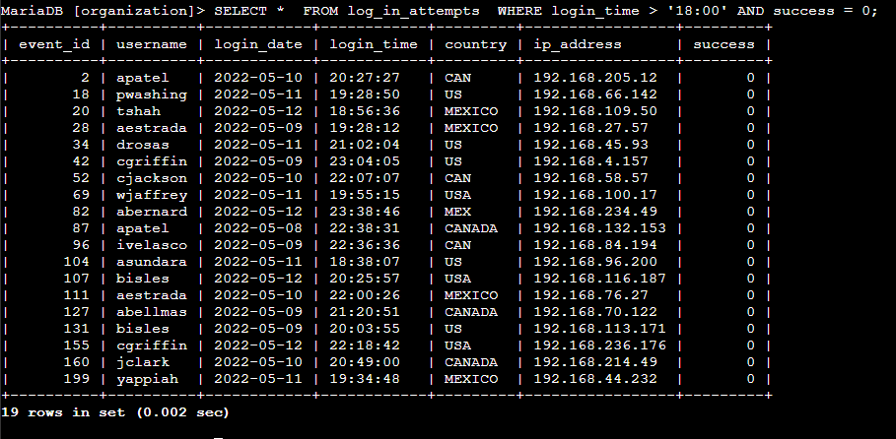

In this case, I am querying any login attempts that happened after 18:00, with the status 0, meaning that the attempts have been failed.

## Retrieve login attempts on specific dates

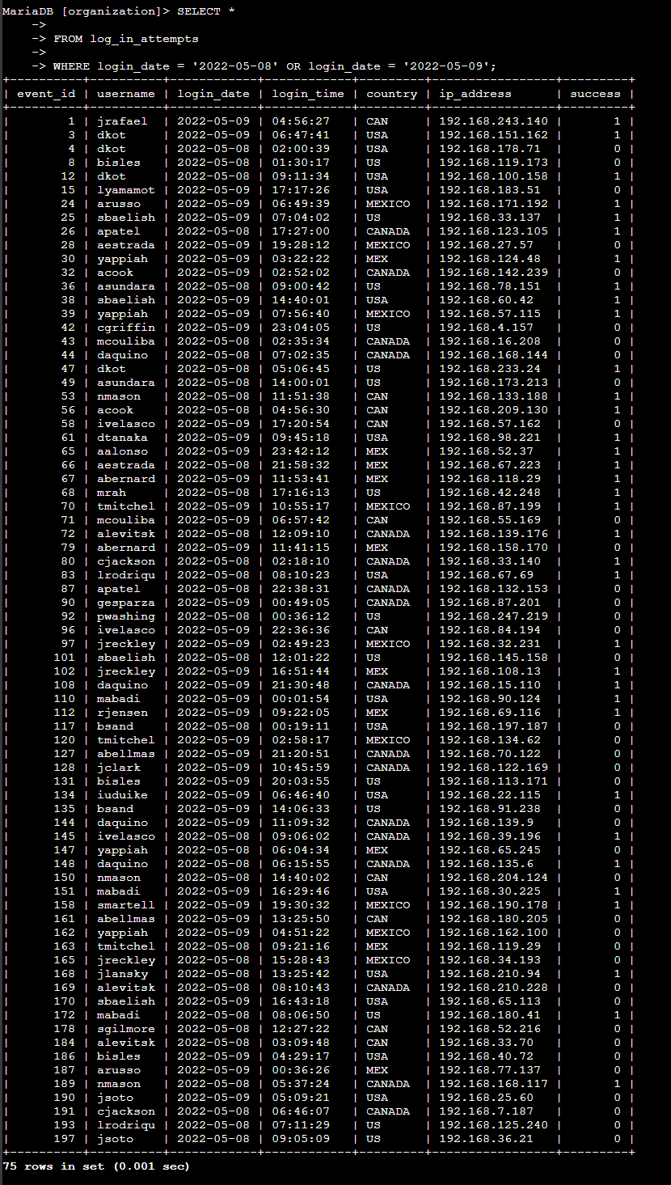

This time, I have specified the date range by using OR command. I get to view all events that happened on these dates.

## Retrieve login attempts outside of Mexico

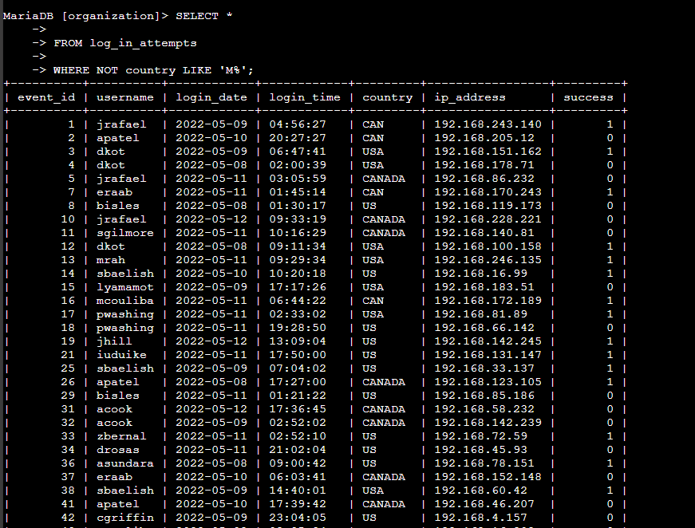

This time, I filter by where the country does NOT begin with M. LIKE ‘M%’ means it includes everything that starts with M, so I can include both MEX and MEXICO entries.

## Retrieve employees in Marketing

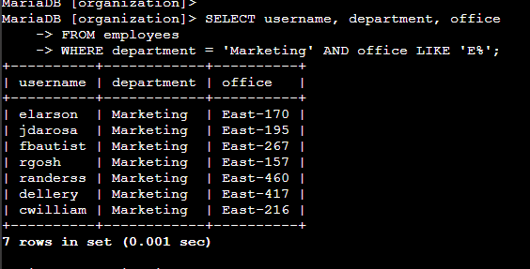

I am looking for all the employees who work in the Marketing department whose office is located on the East side of the building. This was implemented by filtering with matching department names, and all the records that begin with E.

## Retrieve employees in Finance or Sales

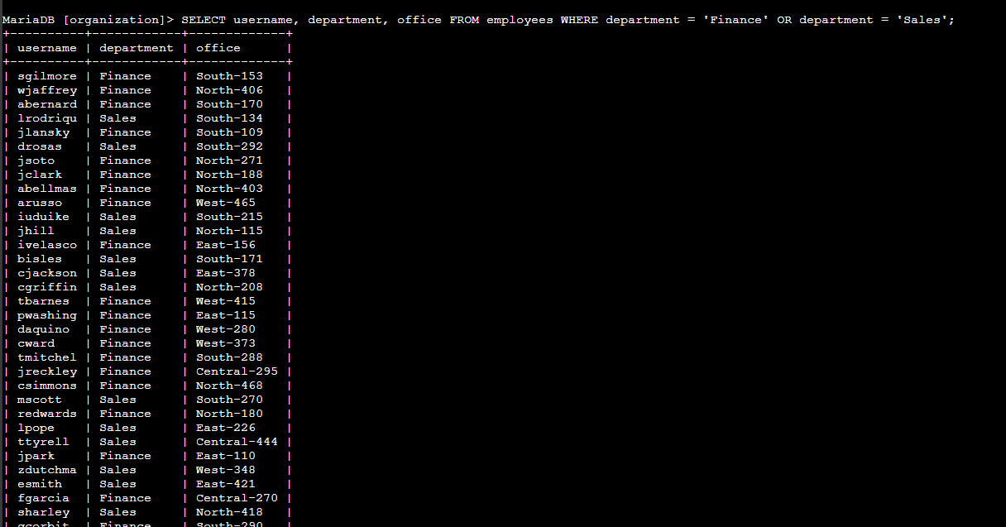

Similar to previous, I am looking for either Finance or Sales department employees. OR is used.

## Retrieve all employees not in IT

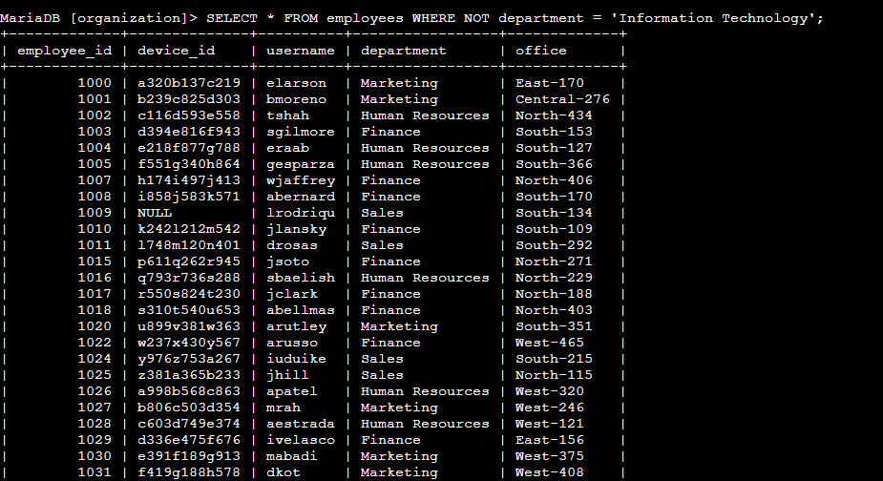

This time, I used NOT to filter out those who are not a part of the IT department.

## Summary

All in all, it was straightforward and I successfully filtered out the database to meet the needs. In summary, SQL query filtering was done by using AND, OR, NOT, BETWEEN, and LIKE.